**Name:** Swagat Panda

**ID:** 2017B5A30983P

**Lab V**

**Study of Instrumentation Amplifier using LM741**

Objectives

To study the Instrumentation Amplifier using op-amp LM741 and find out

1. Value of resistance (Rf) for DC null point,
2. Common mode gain (Acm) for the instrumentation amplifier,
3. Differential mode gain(Adm)for the instrumentation amplifier

and find

* 1. the common mode rejection ratio (CMRR) for the instrumentation amplifier,
  2. compare the results from simulation with the theoretical values of the quantities.

Also, draw schematic for each case.

Instrumentation Amplifier

An **instrumentation amplifier** is a type of differential amplifier that has been outfitted with input buffer amplifiers, which eliminate the need for input impedance matching and thus make the amplifier particularly suitable for use in measurement and test equipment.

Additional characteristics include **very low DC offset, low drift, low noise, very high open-loop gain, very high common-mode rejection ratio**, and **very high input impedances**. Instrumentation amplifiers are used where great accuracy and stability of the circuit both short and long-term are required.

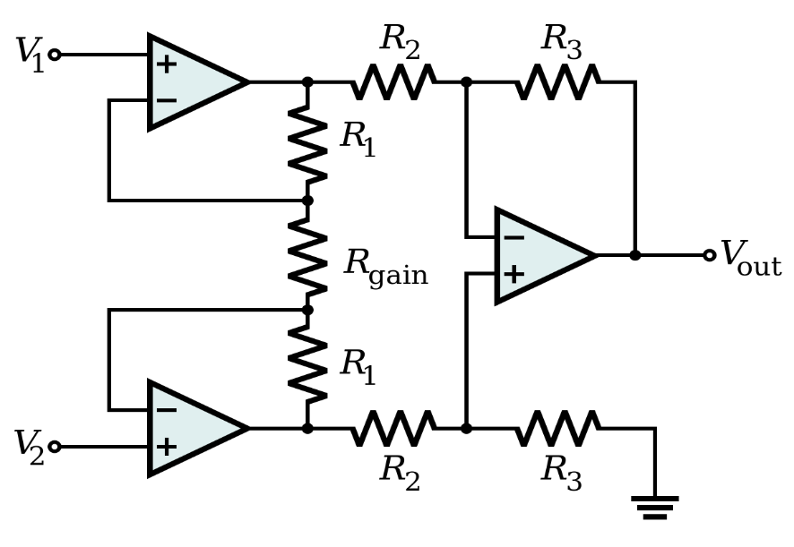

1. DC Null Point

**Schematic and results from .op analysis with .step param**

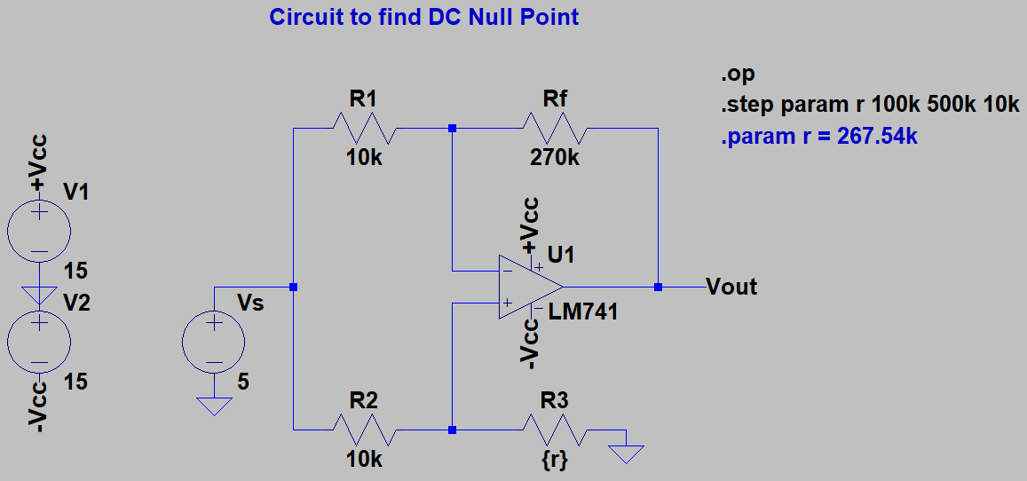

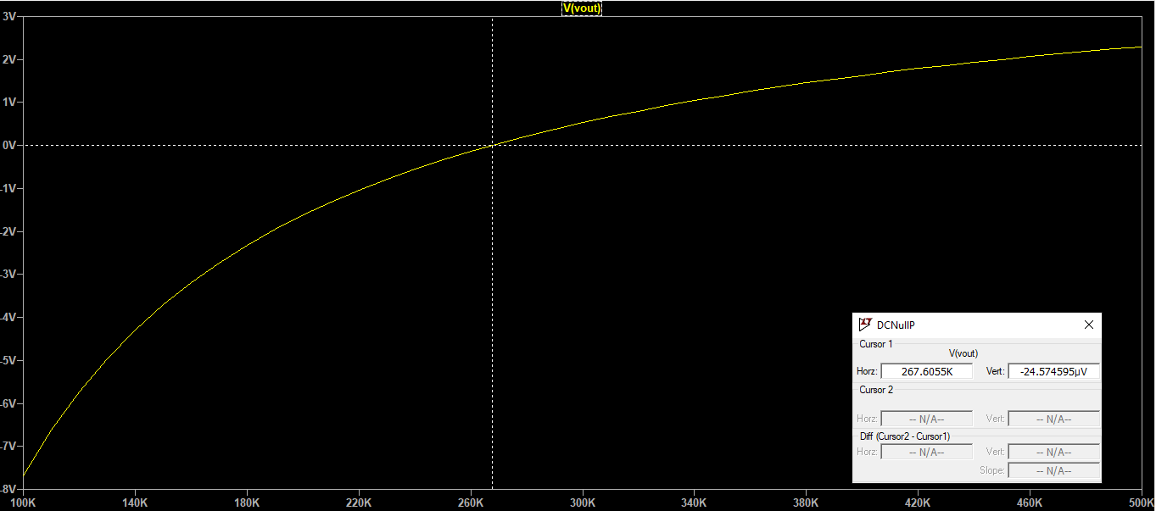

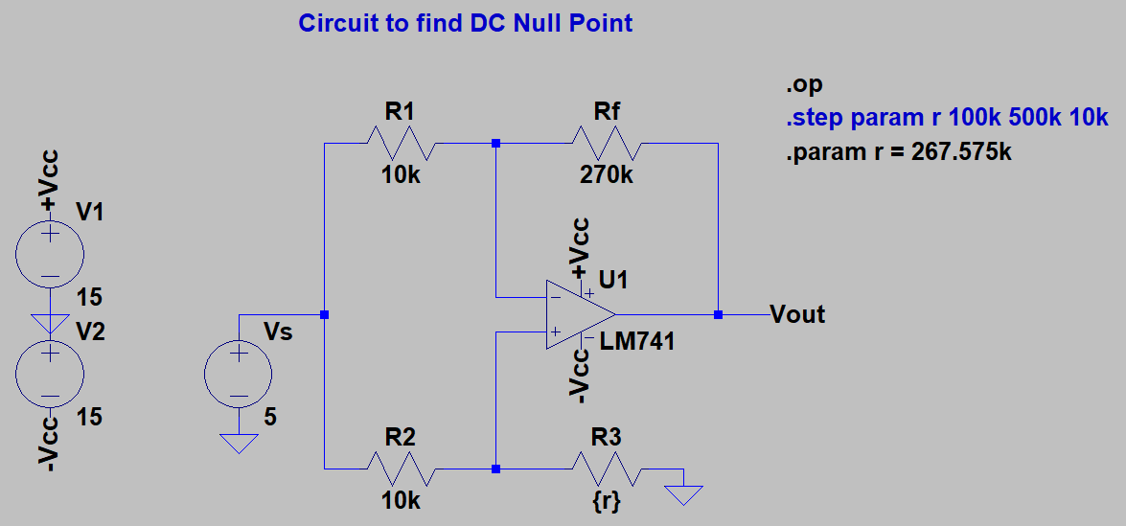

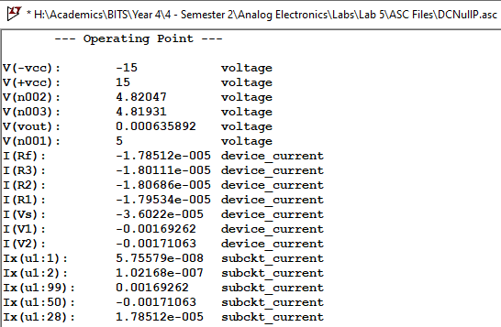

Results

The value of resistance Rf at DC null point (Vout = -9 nV ≈ 0V) comes out to be approximately 267.575 kΩ.

1. Common Mode Gain (Acm)

**Schematic and results from AC analysis** 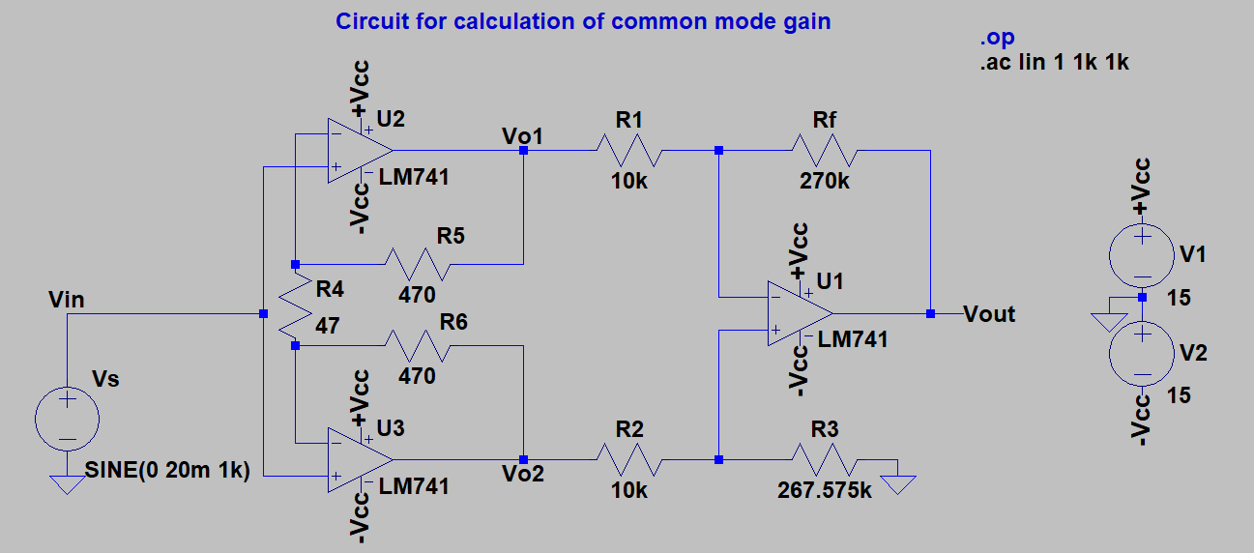

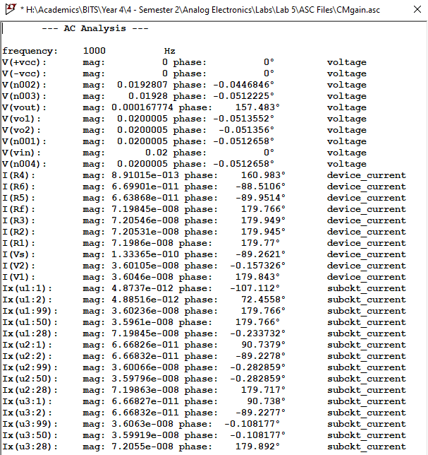

Results

* The value of common mode gain from simulation comes out to be
$$A_{cm}={V_{out}}/{V_{in}}=8.387×{10}^{-3}=-41.527 dB$$

* The theoretical value of common mode gain should be

$$A_{cm}=0$$

1. Differential Mode Gain Adm

Schematic and results from AC analysis

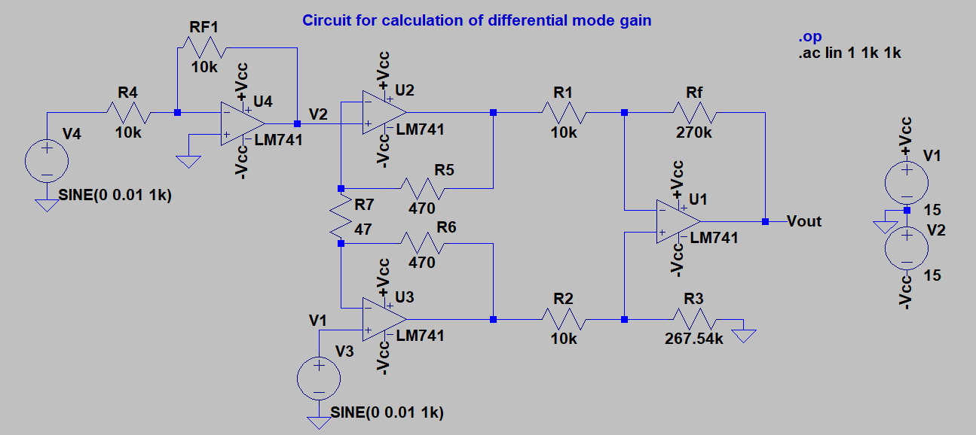

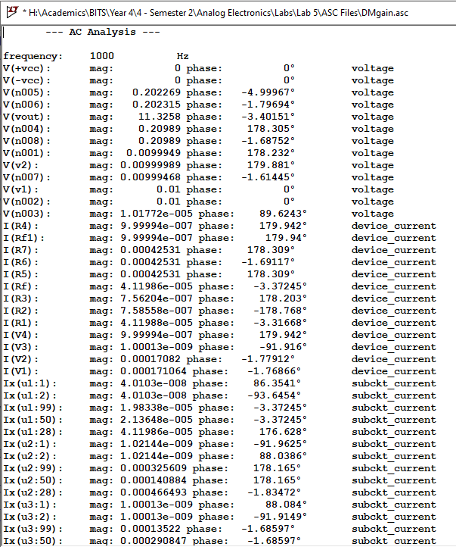

Results

* The value of differential mode gain from simulation comes out to be
$$A_{dm}={V_{out}}/{(V_{1}-V_{2})}=566.29=55.06 dB$$

* The theoretical value of differential mode gain should be

$$A_{dm}=\left(1+\frac{2R_{5}}{R_{7}}\right)\frac{R_{F}}{R_{1}}=567=55.07 dB$$

Calculation of CMRR

The simulated value of common mode rejection ratio (CMRR) is:

$$\frac{A_{dm}}{A_{cm}}=\frac{566.29}{8.387×{10}^{-3}}=67519.97=96.58 dB$$

The theoretical value of CMRR is: infinity.

Conclusions

Hence, practical circuits like the instrumentation amplifier using LM 741 do not have ideal infinite CMRR but are limited to some finite large value due to mismatch. The theoretical value of CMRR is much higher than simulated value as per calculations.